UNITED STATES
SECURITIES AND EXCHANGE COMMISSION
Washington, DC 20549
FORM 8-K
CURRENT REPORT
Pursuant to Section 13 OR 15(d) of the
Securities Exchange Act of 1934
Date of Report (Date of earliest event reported): May 11, 2026
Carlyle Secured Lending, Inc.
(Exact name of registrant as specified in its charter)
Maryland |  |  |  |  |  | 814-00995 |  |  |  |  |  |  |  |  | 80-0789789
(State or Other Jurisdiction  of Incorporation) |  |  |  |  |  | (Commission  File Number) |  |  |  |  |  |  |  |  | (IRS Employer  Identification No.)
One Vanderbilt Avenue, Suite 3400
New York |  |  |  |  |  | New York |  |  |  |  |  |  |  |  | 10017
(Address of Principal Executive Offices) |  |  |  |  |  |  |  |  |  |  |  |  |  |  | (Zip Code)
(212) 813-4900
(Registrant’s Telephone Number, Including Area Code)
Not Applicable
(Former Name or Former Address, if Changed Since Last Report)
Check the appropriate box below if the Form 8-K filing is intended to simultaneously satisfy the filing obligation of the registrant under any of the following provisions (see General Instruction A.2. below):
☐ |  |  | Written communications pursuant to Rule 425 under the Securities Act (17 CFR 230.425)
☐ |  |  | Soliciting material pursuant to Rule 14a-12 under the Exchange Act (17 CFR 240.14a-12)
☐ |  |  | Pre-commencement communications pursuant to Rule 14d-2(b) under the Exchange Act (17 CFR 240.14d-2(b))
☐ |  |  | Pre-commencement communications pursuant to Rule 13e-4(c) under the Exchange Act (17 CFR 240.13e-4(c))

Securities registered pursuant to Section 12(b) of the Act:
Title of each class |  |  | Trading Symbol(s) |  |  | Name of each exchange on which registered
Common Stock |  |  | CGBD |  |  | The Nasdaq Global Select Market
Indicate by check mark whether the registrant is an emerging growth company as defined in Rule 405 of the Securities Act of 1933 (§230.405 of this chapter) or Rule 12b-2 of the Securities Exchange Act of 1934 (§240.12b-2 of this chapter).
Emerging growth company ☐
If an emerging growth company, indicate by check mark if the registrant has elected not to use the extended transition period for complying with any new or revised financial accounting standards provided pursuant to Section 13(a) of the Exchange Act. ☐

Item 2.02 – Results of Operations and Financial Condition.
On May 11, 2026, Carlyle Secured Lending, Inc. (the “Company”) issued a press release announcing its first quarter ended March 31, 2026 financial results and a detailed earnings presentation. Copies of the press release and the earnings presentation are attached hereto as Exhibit 99.1 and Exhibit 99.2, respectively.
The information disclosed under this Item 2.02, including Exhibits 99.1 and 99.2 hereto, is being furnished and shall not be deemed “filed” for purposes of Section 18 of the Securities Exchange Act of 1934 (the “Exchange Act”), and shall not be deemed incorporated by reference into any filing made under the Securities Act of 1933 (the “Securities Act”) or the Exchange Act, except as expressly set forth by specific reference in such filing.
Item 7.01 – Regulation FD Disclosure.
On May 11, 2026, the Company issued a press release, included herewith as Exhibit 99.1, announcing its first quarter ended 2026 financial results and the declaration of a second quarter 2026 dividend of $0.35 per share payable on July 16, 2026 to stockholders of record as of June 30, 2026.
The information disclosed under this Item 7.01, including Exhibit 99.1 hereto, is being furnished and shall not be deemed “filed” for purposes of Section 18 of the Exchange Act, and shall not be deemed incorporated by reference into any filing made under the Securities Act or the Exchange Act, except as expressly set forth by specific reference in such filing.

Item 9.01 – Financial Statements and Exhibits.
Exhibits 99.1 and 99.2 shall be deemed furnished herewith.

(d)Exhibits:
Exhibit Number |  |  |  |  |  | Description
99.1 |  |  |  |  |  | Earnings press release of Carlyle Secured Lending, Inc., dated May 11, 2026.
99.2 |  |  |  |  |  | Earnings presentation of Carlyle Secured Lending, Inc., dated May 11, 2026

SIGNATURES
Pursuant to the requirements of the Securities Exchange Act of 1934, the Registrant has duly caused this report to be signed on its behalf by the undersigned hereunto duly authorized.
 |  |  |  |  |  |  |  |  |  |  |  | CARLYLE SECURED LENDING, INC.
 |  |  |  |  |  |  |  |  |  |  |  | (Registrant)
Dated: May 11, 2026 |  |  |  |  |  | By: |  |  |  |  |  | /s/ Thomas M. Hennigan
 |  |  |  |  |  |  |  |  |  |  |  | Name: Thomas M. Hennigan
Title: Director, President, Chief Financial Officer and Chief Risk Officer
(principal financial officer)

Exhibit 99.1



For Immediate Release
May 11, 2026

Carlyle Secured Lending, Inc. Announces Financial Results For First Quarter Ended March 31, 2026, Declares Second Quarter 2026 Dividend of $0.35 Per Common Share
New York - Carlyle Secured Lending, Inc. (together with its consolidated subsidiaries, “we,” “us,” “our,” “CGBD” or the “Company”) (NASDAQ: CGBD) today announced its financial results for its first quarter ended March 31, 2026.
Alex Chi, CGBD’s Chief Executive Officer, said, “Despite macroeconomic uncertainty and market volatility, CGBD delivered another quarter of stable earnings, supported by consistent credit performance. We are seeing an increasingly attractive investment environment, with spreads on new originations expanding, positioning the portfolio for improved yields and stronger earnings power over time. In this context, we have reset the base dividend to better align with current portfolio earnings, while maintaining the potential to deliver additional value to shareholders through supplemental dividends as earnings grow. We believe this approach enhances our financial flexibility and supports a stable NAV. We remain focused on leveraging the OneCarlyle platform and enhancing our origination engine to take market share, as well as scaling our joint ventures which both ended the quarter with over $1 billion in assets.”
For the first quarter of 2026, we reported $0.36 per common share of Net Investment Income and Adjusted Net Investment Income, a non-GAAP financial measure described below.
Net asset value per common share decreased by 2.3% for the first quarter to $15.89 from $16.26 as of December 31, 2025. The total fair value of our investments decreased to $2.3 billion as of March 31, 2026.
Dividends
On April 29, 2026, the Board of Directors declared a quarterly common dividend of $0.35 per share. The dividend is payable on July 16, 2026 to common stockholders of record on June 30, 2026.
Conference Call
The Company will host a conference call at 12:00 p.m. (Eastern Time) on Monday, May 11, 2026 to discuss these financial results. The conference call will be available via public webcast via a link on our website and will also be available on our website soon after the call’s completion.
Non-GAAP Financial Measures
On a supplemental basis, we are disclosing Adjusted Net Investment Income Per Common Share, which is calculated and presented on a basis other than in accordance with GAAP (“non-GAAP”). We use this non-GAAP financial measure internally to analyze and evaluate financial results and performance, and we believe this non-GAAP financial measure is useful to investors as an additional tool to evaluate our ongoing results and trends and to review our performance without giving effect to (i) the amortization/accretion resulting from the new cost basis of the investments acquired and accounted for under the acquisition method of accounting in accordance with ASC 805 and (ii) the one-time purchase or non-recurring investment income and expense events, including the effects on incentive fees. In addition, the Company’s management uses the non-GAAP financial measure described above internally to analyze and evaluate financial results and performance and to compare the Company’s financial results with those of other business development companies that have not had similar one-time or non-recurring events. The presentation of this non-GAAP measure is not intended to be a substitute for financial results prepared in accordance with GAAP and should not be considered in isolation.
Starting in the first quarter of 2025, the adjustment to net investment income per common share to determine Adjusted Net Investment Income Per Common Share represents the difference between GAAP amortization under the asset acquisition method of accounting in accordance with ASC 805 and management’s non-GAAP measure of amortization related to assets acquired in connection with the CSL III merger on March 27, 2025, and the remaining interest in Middle Market Credit Fund II on

Page | 1
February 11, 2025. This adjustment reflects management’s view of the economic yield on the acquired assets and is consistent with our internal evaluation of performance.
Carlyle Secured Lending, Inc.
CGBD is an externally managed specialty finance company focused on lending to middle-market companies. CGBD is managed by Carlyle Global Credit Investment Management L.L.C., an SEC-registered investment adviser and a wholly owned subsidiary of The Carlyle Group Inc. Since it commenced investment operations in May 2013 through March 31, 2026, CGBD has invested approximately $10.9 billion in aggregate principal amount of debt and equity investments prior to any subsequent exits or repayments. CGBD’s investment objective is to generate current income and capital appreciation primarily through debt investments in U.S. middle market companies. CGBD has elected to be regulated as a business development company under the Investment Company Act of 1940, as amended.
Web: carlylesecuredlending.com
About Carlyle
Carlyle (“Carlyle,” or the “Adviser”) (NASDAQ: CG) is a global investment firm with deep industry expertise that deploys private capital across three business segments: Global Private Equity, Global Credit, and Carlyle AlpInvest. With $475 billion of assets under management as of March 31, 2026, Carlyle’s purpose is to invest wisely and create value on behalf of its investors, portfolio companies, and the communities in which we live and invest. Carlyle employs more than 2,500 people in 28 offices across four continents. Further information is available at www.carlyle.com. Follow Carlyle on X @OneCarlyle and LinkedIn at The Carlyle Group.

Contacts:
Investors: |  |  | Media:
Nishil Mehta |  |  | Brittany Bensaull
+1-212-813-4918 |  |  | +1-212-813-4839
publicinvestor@carlylesecuredlending.com |  |  | brittany.bensaull@carlyle.com

Page | 2
1 Carlyle Secured Lending, Inc. Quarterly Earnings Presentation March 31, 2026

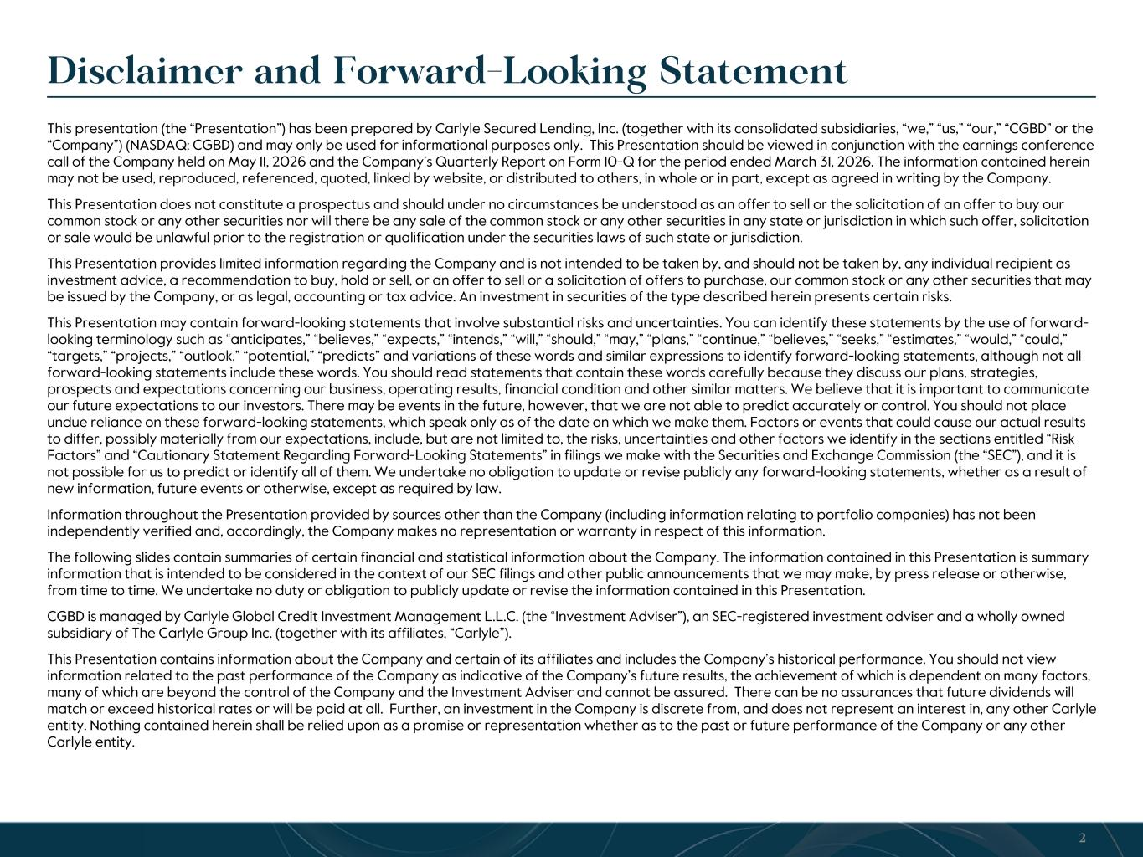
Disclaimer and Forward-Looking Statement This presentation (the “Presentation”) has been prepared by Carlyle Secured Lending, Inc. (together with its consolidated subsidiaries, “we,” “us,” “our,” “CGBD” or the “Company”) (NASDAQ: CGBD) and may only be used for informational purposes only. This Presentation should be viewed in conjunction with the earnings conference call of the Company held on May 11, 2026 and the Company’s Quarterly Report on Form 10-Q for the period ended March 31, 2026. The information contained herein may not be used, reproduced, referenced, quoted, linked by website, or distributed to others, in whole or in part, except as agreed in writing by the Company. This Presentation does not constitute a prospectus and should under no circumstances be understood as an offer to sell or the solicitation of an offer to buy our common stock or any other securities nor will there be any sale of the common stock or any other securities in any state or jurisdiction in which such offer, solicitation or sale would be unlawful prior to the registration or qualification under the securities laws of such state or jurisdiction. This Presentation provides limited information regarding the Company and is not intended to be taken by, and should not be taken by, any individual recipient as investment advice, a recommendation to buy, hold or sell, or an offer to sell or a solicitation of offers to purchase, our common stock or any other securities that may be issued by the Company, or as legal, accounting or tax advice. An investment in securities of the type described herein presents certain risks. This Presentation may contain forward-looking statements that involve substantial risks and uncertainties. You can identify these statements by the use of forward- looking terminology such as “anticipates,” “believes,” “expects,” “intends,” “will,” “should,” “may,” “plans,” “continue,” “believes,” “seeks,” “estimates,” “would,” “could,” “targets,” “projects,” “outlook,” “potential,” “predicts” and variations of these words and similar expressions to identify forward-looking statements, although not all forward-looking statements include these words. You should read statements that contain these words carefully because they discuss our plans, strategies, prospects and expectations concerning our business, operating results, financial condition and other similar matters. We believe that it is important to communicate our future expectations to our investors. There may be events in the future, however, that we are not able to predict accurately or control. You should not place undue reliance on these forward-looking statements, which speak only as of the date on which we make them. Factors or events that could cause our actual results to differ, possibly materially from our expectations, include, but are not limited to, the risks, uncertainties and other factors we identify in the sections entitled “Risk Factors” and “Cautionary Statement Regarding Forward-Looking Statements” in filings we make with the Securities and Exchange Commission (the “SEC”), and it is not possible for us to predict or identify all of them. We undertake no obligation to update or revise publicly any forward-looking statements, whether as a result of new information, future events or otherwise, except as required by law. Information throughout the Presentation provided by sources other than the Company (including information relating to portfolio companies) has not been independently verified and, accordingly, the Company makes no representation or warranty in respect of this information. The following slides contain summaries of certain financial and statistical information about the Company. The information contained in this Presentation is summary information that is intended to be considered in the context of our SEC filings and other public announcements that we may make, by press release or otherwise, from time to time. We undertake no duty or obligation to publicly update or revise the information contained in this Presentation. CGBD is managed by Carlyle Global Credit Investment Management L.L.C. (the “Investment Adviser”), an SEC-registered investment adviser and a wholly owned subsidiary of The Carlyle Group Inc. (together with its affiliates, “Carlyle”). This Presentation contains information about the Company and certain of its affiliates and includes the Company’s historical performance. You should not view information related to the past performance of the Company as indicative of the Company’s future results, the achievement of which is dependent on many factors, many of which are beyond the control of the Company and the Investment Adviser and cannot be assured. There can be no assurances that future dividends will match or exceed historical rates or will be paid at all. Further, an investment in the Company is discrete from, and does not represent an interest in, any other Carlyle entity. Nothing contained herein shall be relied upon as a promise or representation whether as to the past or future performance of the Company or any other Carlyle entity. 2

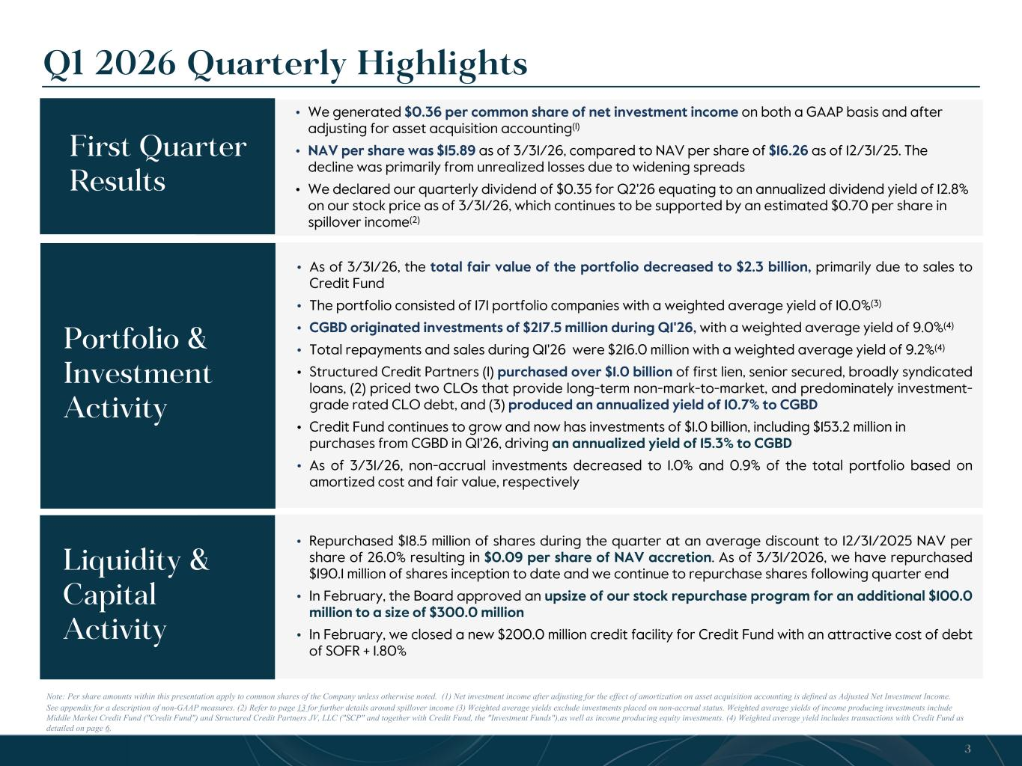
• As of 3/31/26, the total fair value of the portfolio decreased to $2.3 billion, primarily due to sales to Credit Fund • The portfolio consisted of 171 portfolio companies with a weighted average yield of 10.0%(3) • CGBD originated investments of $217.5 million during Q1'26, with a weighted average yield of 9.0%(4) • Total repayments and sales during Q1'26 were $216.0 million with a weighted average yield of 9.2%(4) • Structured Credit Partners (1) purchased over $1.0 billion of first lien, senior secured, broadly syndicated loans, (2) priced two CLOs that provide long-term non-mark-to-market, and predominately investment- grade rated CLO debt, and (3) produced an annualized yield of 10.7% to CGBD • Credit Fund continues to grow and now has investments of $1.0 billion, including $153.2 million in purchases from CGBD in Q1'26, driving an annualized yield of 15.3% to CGBD • As of 3/31/26, non-accrual investments decreased to 1.0% and 0.9% of the total portfolio based on amortized cost and fair value, respectively • We repurchased [0.8 million of additional shares in 2026 for $8.8 million resulting in an additional $0.05 per share of accretion based on 12/31/2025 NAV and increasing our inception to date share repurchases to $198.9 million](5) • Repurchased $18.5 million of shares during the quarter at an average discount to 12/31/2025 NAV per share of 26.0% resulting in $0.09 per share of NAV accretion. As of 3/31/2026, we have repurchased $190.1 million of shares inception to date and we continue to repurchase shares following quarter end • In February, the Board approved an upsize of our stock repurchase program for an additional $100.0 million to a size of $300.0 million • In February, we closed a new $200.0 million credit facility for Credit Fund with an attractive cost of debt of SOFR + 1.80% Q1 2026 Quarterly Highlights 3 Note: Per share amounts within this presentation apply to common shares of the Company unless otherwise noted. (1) Net investment income after adjusting for the effect of amortization on asset acquisition accounting is defined as Adjusted Net Investment Income. See appendix for a description of non-GAAP measures. (2) Refer to page 13 for further details around spillover income (3) Weighted average yields exclude investments placed on non-accrual status. Weighted average yields of income producing investments include Middle Market Credit Fund ("Credit Fund") and Structured Credit Partners JV, LLC ("SCP" and together with Credit Fund, the "Investment Funds"),as well as income producing equity investments. (4) Weighted average yield includes transactions with Credit Fund as detailed on page 6. • We generated $0.36 per common share of net investment income on both a GAAP basis and after adjusting for asset acquisition accounting(1) • NAV per share was $15.89 as of 3/31/26, compared to NAV per share of $16.26 as of 12/31/25. The decline was primarily from unrealized losses due to widening spreads • We declared our quarterly dividend of $0.35 for Q2'26 equating to an annualized dividend yield of 12.8% on our stock price as of 3/31/26, which continues to be supported by an estimated $0.70 per share in spillover income(2) First Quarter Results Portfolio & Investment Activity Liquidity & Capital Activity Recent Developments

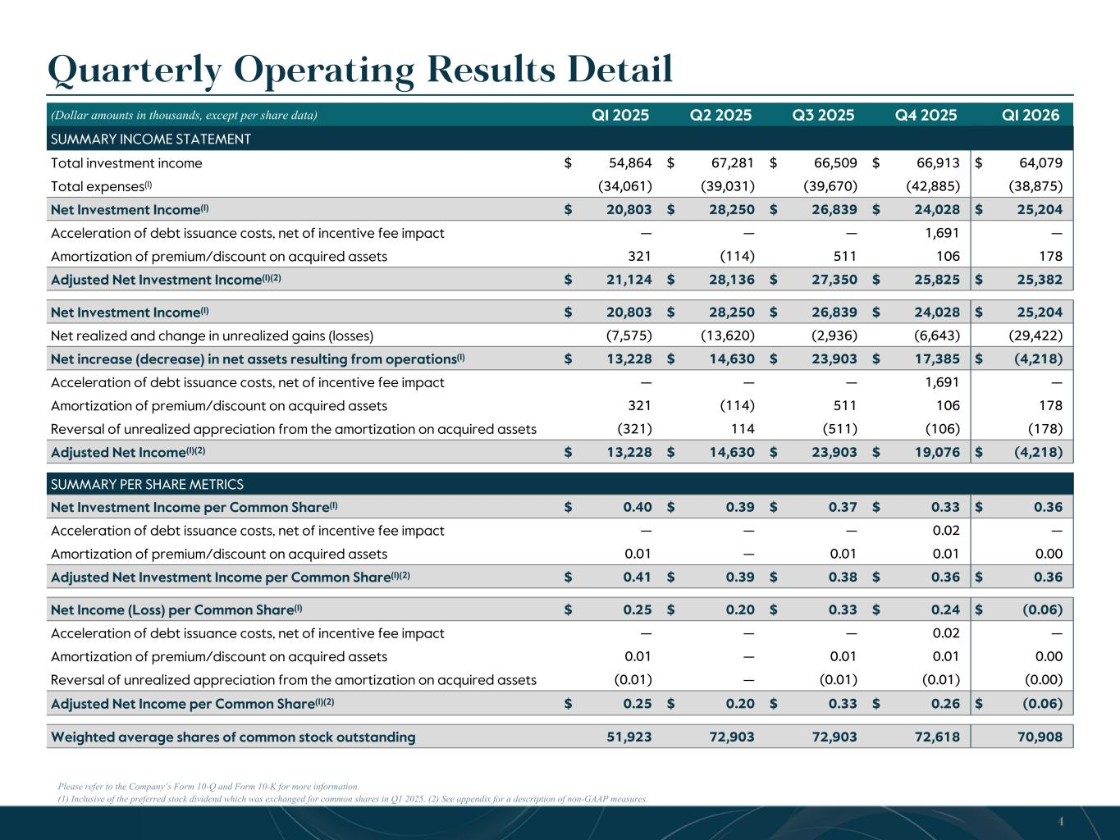
Quarterly Operating Results Detail Please refer to the Company’s Form 10-Q and Form 10-K for more information. (1) Inclusive of the preferred stock dividend which was exchanged for common shares in Q1 2025. (2) See appendix for a description of non-GAAP measures. (Dollar amounts in thousands, except per share data) Q1 2025 Q2 2025 Q3 2025 Q4 2025 Q1 2026 SUMMARY INCOME STATEMENT Total investment income $ 54,864 $ 67,281 $ 66,509 $ 66,913 $ 64,079 Total expenses(1) (34,061) (39,031) (39,670) (42,885) (38,875) Net Investment Income(1) $ 20,803 $ 28,250 $ 26,839 $ 24,028 $ 25,204 Acceleration of debt issuance costs, net of incentive fee impact — — — 1,691 — Amortization of premium/discount on acquired assets 321 (114) 511 106 178 Adjusted Net Investment Income(1)(2) $ 21,124 $ 28,136 $ 27,350 $ 25,825 $ 25,382 Net Investment Income(1) $ 20,803 $ 28,250 $ 26,839 $ 24,028 $ 25,204 Net realized and change in unrealized gains (losses) (7,575) (13,620) (2,936) (6,643) (29,422) Net increase (decrease) in net assets resulting from operations(1) $ 13,228 $ 14,630 $ 23,903 $ 17,385 $ (4,218) Acceleration of debt issuance costs, net of incentive fee impact — — — 1,691 — Amortization of premium/discount on acquired assets 321 (114) 511 106 178 Reversal of unrealized appreciation from the amortization on acquired assets (321) 114 (511) (106) (178) Adjusted Net Income(1)(2) $ 13,228 $ 14,630 $ 23,903 $ 19,076 $ (4,218) SUMMARY PER SHARE METRICS Net Investment Income per Common Share(1) $ 0.40 $ 0.39 $ 0.37 $ 0.33 $ 0.36 Acceleration of debt issuance costs, net of incentive fee impact — — — 0.02 — Amortization of premium/discount on acquired assets 0.01 — 0.01 0.01 0.00 Adjusted Net Investment Income per Common Share(1)(2) $ 0.41 $ 0.39 $ 0.38 $ 0.36 $ 0.36 Net Income (Loss) per Common Share(1) $ 0.25 $ 0.20 $ 0.33 $ 0.24 $ (0.06) Acceleration of debt issuance costs, net of incentive fee impact — — — 0.02 — Amortization of premium/discount on acquired assets 0.01 — 0.01 0.01 0.00 Reversal of unrealized appreciation from the amortization on acquired assets (0.01) — (0.01) (0.01) (0.00) Adjusted Net Income per Common Share(1)(2) $ 0.25 $ 0.20 $ 0.33 $ 0.26 $ (0.06) Weighted average shares of common stock outstanding 51,923 72,903 72,903 72,618 70,908 4

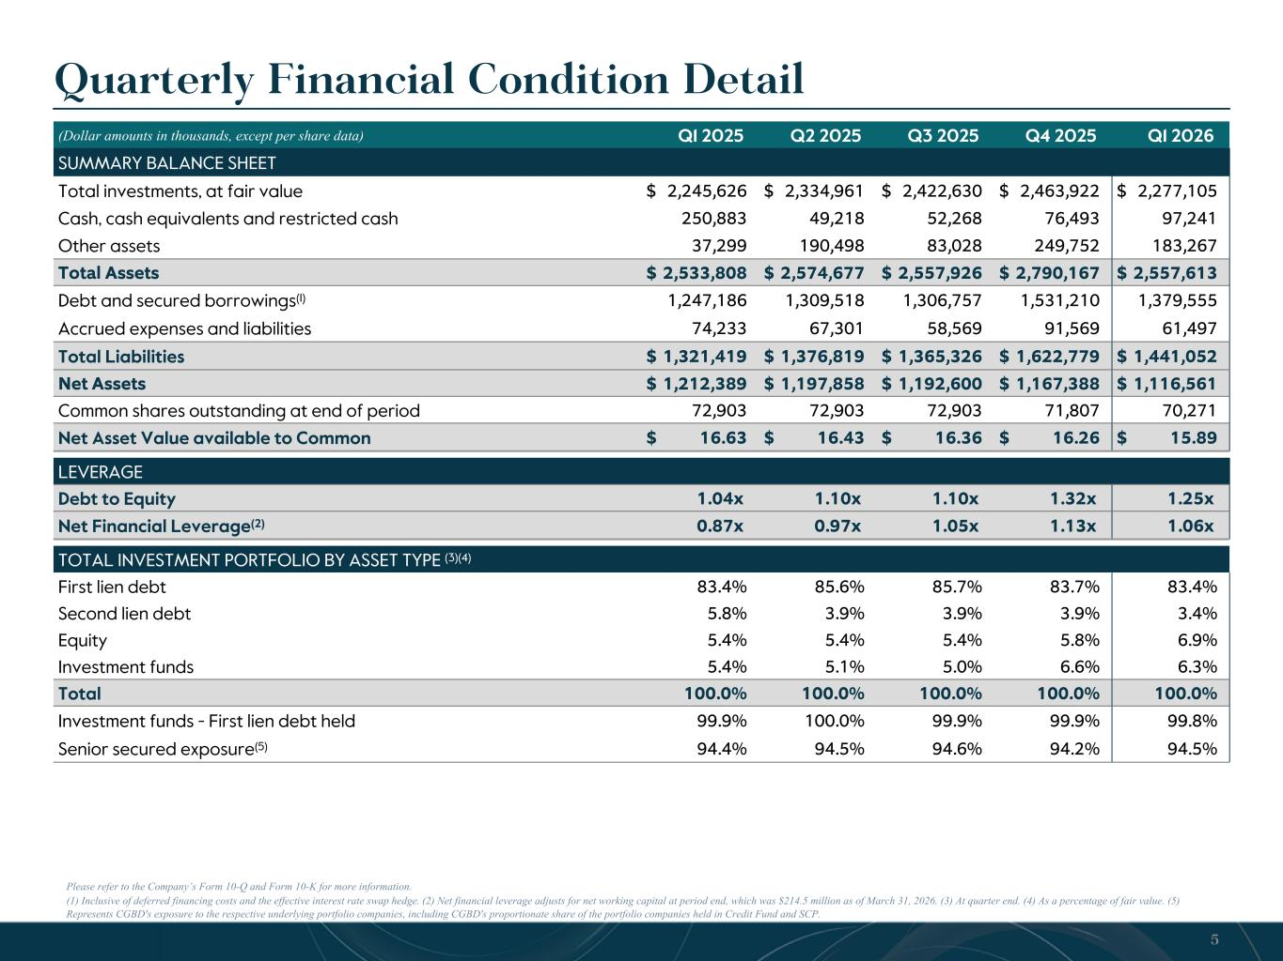
Please refer to the Company’s Form 10-Q and Form 10-K for more information. (1) Inclusive of deferred financing costs and the effective interest rate swap hedge. (2) Net financial leverage adjusts for net working capital at period end, which was $214.5 million as of March 31, 2026. (3) At quarter end. (4) As a percentage of fair value. (5) Represents CGBD's exposure to the respective underlying portfolio companies, including CGBD's proportionate share of the portfolio companies held in Credit Fund and SCP. Quarterly Financial Condition Detail (Dollar amounts in thousands, except per share data) Q1 2025 Q2 2025 Q3 2025 Q4 2025 Q1 2026 SUMMARY BALANCE SHEET Total investments, at fair value $ 2,245,626 $ 2,334,961 $ 2,422,630 $ 2,463,922 $ 2,277,105 Cash, cash equivalents and restricted cash 250,883 49,218 52,268 76,493 97,241 Other assets 37,299 190,498 83,028 249,752 183,267 Total Assets $ 2,533,808 $ 2,574,677 $ 2,557,926 $ 2,790,167 $ 2,557,613 Debt and secured borrowings(1) 1,247,186 1,309,518 1,306,757 1,531,210 1,379,555 Accrued expenses and liabilities 74,233 67,301 58,569 91,569 61,497 Total Liabilities $ 1,321,419 $ 1,376,819 $ 1,365,326 $ 1,622,779 $ 1,441,052 Net Assets $ 1,212,389 $ 1,197,858 $ 1,192,600 $ 1,167,388 $ 1,116,561 Common shares outstanding at end of period 72,903 72,903 72,903 71,807 70,271 Net Asset Value available to Common $ 16.63 $ 16.43 $ 16.36 $ 16.26 $ 15.89 LEVERAGE Debt to Equity 1.04x 1.10x 1.10x 1.32x 1.25x Net Financial Leverage(2) 0.87x 0.97x 1.05x 1.13x 1.06x TOTAL INVESTMENT PORTFOLIO BY ASSET TYPE (3)(4) First lien debt 83.4 % 85.6 % 85.7 % 83.7 % 83.4 % Second lien debt 5.8 % 3.9 % 3.9 % 3.9 % 3.4 % Equity 5.4 % 5.4 % 5.4 % 5.8 % 6.9 % Investment funds 5.4 % 5.1 % 5.0 % 6.6 % 6.3 % Total 100.0 % 100.0 % 100.0 % 100.0 % 100.0 % Investment funds - First lien debt held 99.9 % 100.0 % 99.9 % 99.9 % 99.8 % Senior secured exposure(5) 94.4 % 94.5 % 94.6 % 94.2 % 94.5 % 5

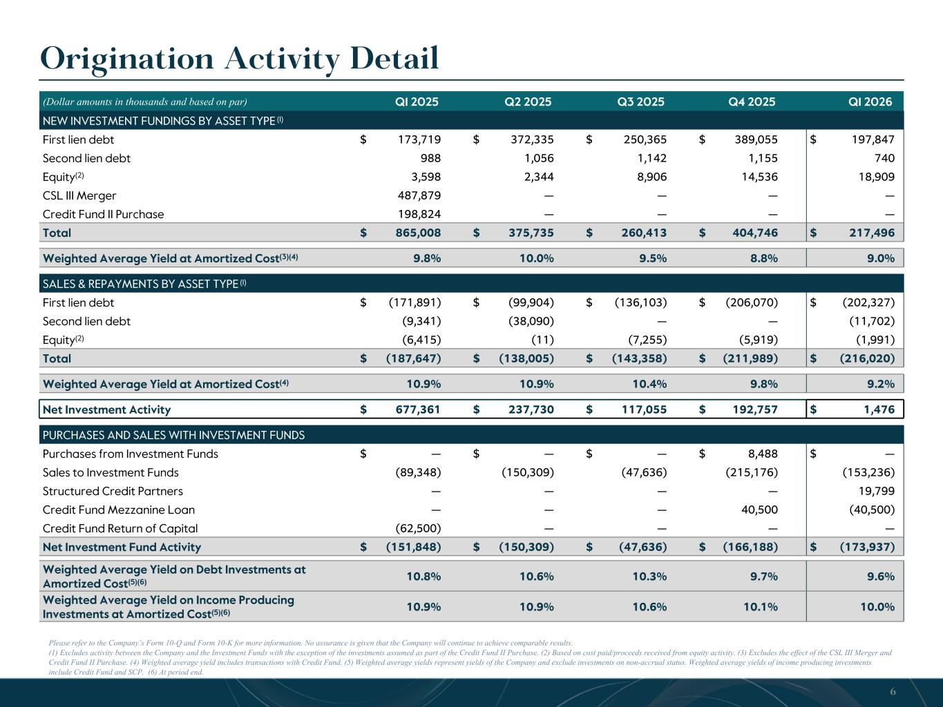
Origination Activity Detail Please refer to the Company’s Form 10-Q and Form 10-K for more information. No assurance is given that the Company will continue to achieve comparable results. (1) Excludes activity between the Company and the Investment Funds with the exception of the investments assumed as part of the Credit Fund II Purchase. (2) Based on cost paid/proceeds received from equity activity. (3) Excludes the effect of the CSL III Merger and Credit Fund II Purchase. (4) Weighted average yield includes transactions with Credit Fund. (5) Weighted average yields represent yields of the Company and exclude investments on non-accrual status. Weighted average yields of income producing investments include Credit Fund and SCP. (6) At period end. (Dollar amounts in thousands and based on par) Q1 2025 Q2 2025 Q3 2025 Q4 2025 Q1 2026 NEW INVESTMENT FUNDINGS BY ASSET TYPE (1) First lien debt $ 173,719 $ 372,335 $ 250,365 $ 389,055 $ 197,847 Second lien debt 988 1,056 1,142 1,155 740 Equity(2) 3,598 2,344 8,906 14,536 18,909 CSL III Merger 487,879 — — — — Credit Fund II Purchase 198,824 — — — — Total $ 865,008 $ 375,735 $ 260,413 $ 404,746 $ 217,496 Weighted Average Yield at Amortized Cost(3)(4) 9.8 % 10.0 % 9.5 % 8.8 % 9.0 % SALES & REPAYMENTS BY ASSET TYPE (1) First lien debt $ (171,891) $ (99,904) $ (136,103) $ (206,070) $ (202,327) Second lien debt (9,341) (38,090) — — (11,702) Equity(2) (6,415) (11) (7,255) (5,919) (1,991) Total $ (187,647) $ (138,005) $ (143,358) $ (211,989) $ (216,020) Weighted Average Yield at Amortized Cost(4) 10.9 % 10.9 % 10.4 % 9.8 % 9.2 % Net Investment Activity $ 677,361 $ 237,730 $ 117,055 $ 192,757 $ 1,476 PURCHASES AND SALES WITH INVESTMENT FUNDS Purchases from Investment Funds $ — $ — $ — $ 8,488 $ — Sales to Investment Funds (89,348) (150,309) (47,636) (215,176) (153,236) Structured Credit Partners — — — — 19,799 Credit Fund Mezzanine Loan — — — 40,500 (40,500) Credit Fund Return of Capital (62,500) — — — — Net Investment Fund Activity $ (151,848) $ (150,309) $ (47,636) $ (166,188) $ (173,937) Weighted Average Yield on Debt Investments at Amortized Cost(5)(6) 10.8 % 10.6 % 10.3 % 9.7 % 9.6 % Weighted Average Yield on Income Producing Investments at Amortized Cost(5)(6) 10.9 % 10.9 % 10.6 % 10.1 % 10.0 % 6

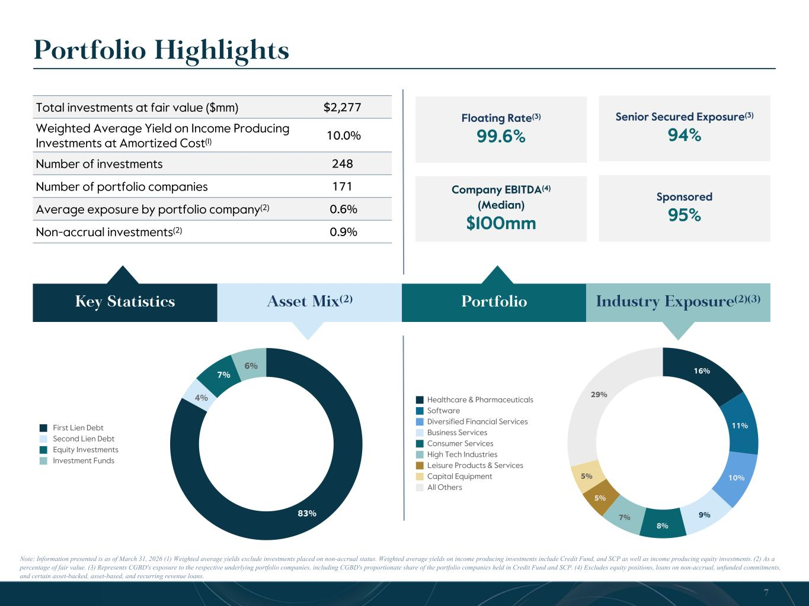
Senior Secured Exposure(3) 94% 83% 4% 7% 6% First Lien Debt Second Lien Debt Equity Investments Investment Funds 16% 11% 10% 9% 8% 7% 5% 5% 29% Healthcare & Pharmaceuticals Software Diversified Financial Services Business Services Consumer Services High Tech Industries Leisure Products & Services Capital Equipment All Others Portfolio Highlights Note: Information presented is as of March 31, 2026 (1) Weighted average yields exclude investments placed on non-accrual status. Weighted average yields on income producing investments include Credit Fund, and SCP as well as income producing equity investments. (2) As a percentage of fair value. (3) Represents CGBD's exposure to the respective underlying portfolio companies, including CGBD's proportionate share of the portfolio companies held in Credit Fund and SCP. (4) Excludes equity positions, loans on non-accrual, unfunded commitments, and certain asset-backed, asset-based, and recurring revenue loans. Total investments at fair value ($mm) $2,277 Weighted Average Yield on Income Producing Investments at Amortized Cost(1) 10.0% Number of investments 248 Number of portfolio companies 171 Average exposure by portfolio company(2) 0.6% Non-accrual investments(2) 0.9% 7 Key Statistics Asset Mix(2) Portfolio Industry Exposure(2)(3) Floating Rate(3) 99.6% Company EBITDA(4) (Median) $100mm Sponsored 95%

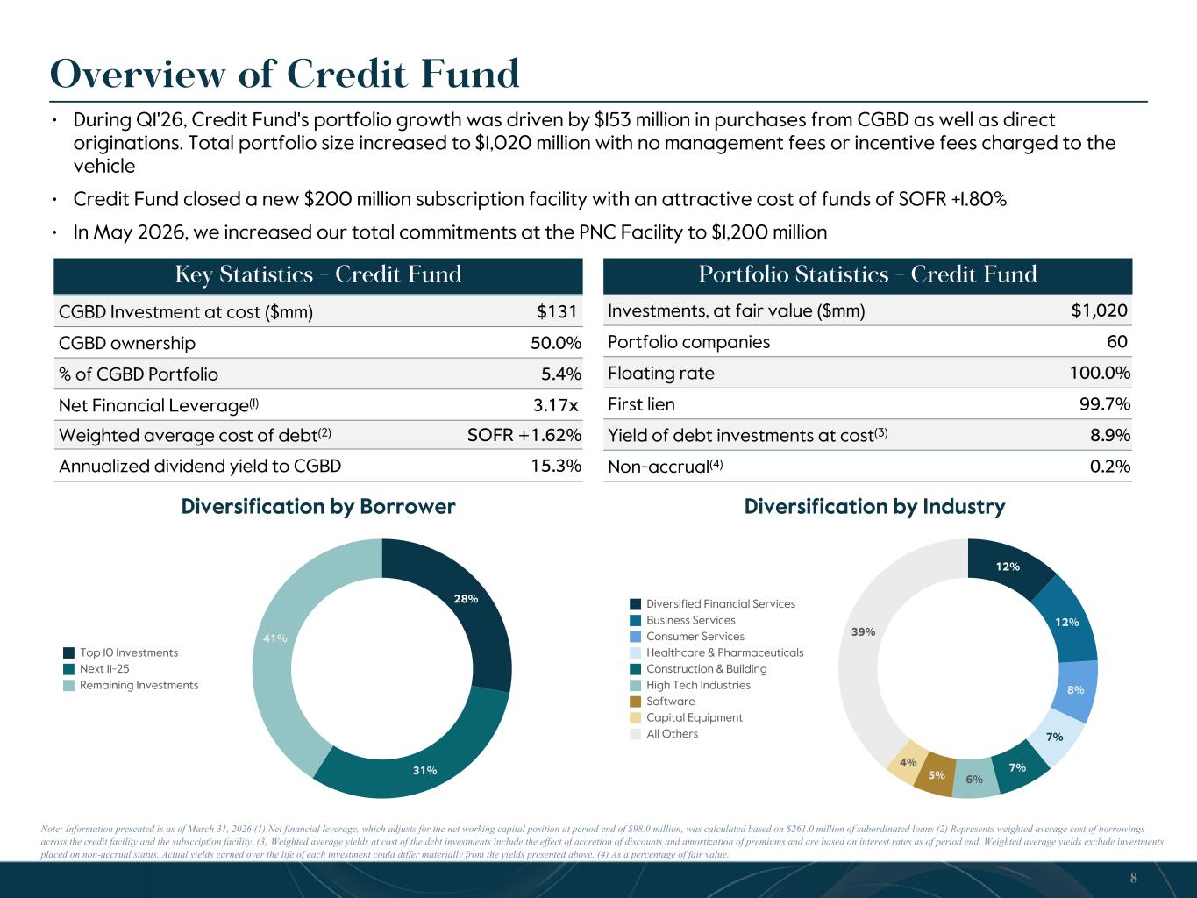
• During Q1'26, Credit Fund's portfolio growth was driven by $153 million in purchases from CGBD as well as direct originations. Total portfolio size increased to $1,020 million with no management fees or incentive fees charged to the vehicle • Credit Fund closed a new $200 million subscription facility with an attractive cost of funds of SOFR +1.80% • In May 2026, we increased our total commitments at the PNC Facility to $1,200 million 28% 31% 41% Top 10 Investments Next 11-25 Remaining Investments 12% 12% 8% 7% 7% 6%5% 4% 39% Diversified Financial Services Business Services Consumer Services Healthcare & Pharmaceuticals Construction & Building High Tech Industries Software Capital Equipment All Others Overview of Credit Fund Note: Information presented is as of March 31, 2026 (1) Net financial leverage, which adjusts for the net working capital position at period end of $98.0 million, was calculated based on $261.0 million of subordinated loans (2) Represents weighted average cost of borrowings across the credit facility and the subscription facility. (3) Weighted average yields at cost of the debt investments include the effect of accretion of discounts and amortization of premiums and are based on interest rates as of period end. Weighted average yields exclude investments placed on non-accrual status. Actual yields earned over the life of each investment could differ materially from the yields presented above. (4) As a percentage of fair value. 8 Diversification by Borrower Diversification by Industry Key Statistics - Credit Fund CGBD Investment at cost ($mm) $131 CGBD ownership 50.0 % % of CGBD Portfolio 5.4 % Net Financial Leverage(1) 3.17x Weighted average cost of debt(2) SOFR +1.62% Annualized dividend yield to CGBD 15.3 % Portfolio Statistics - Credit Fund Investments, at fair value ($mm) $1,020 Portfolio companies 60 Floating rate 100.0 % First lien 99.7 % Yield of debt investments at cost(3) 8.9 % Non-accrual(4) 0.2 %

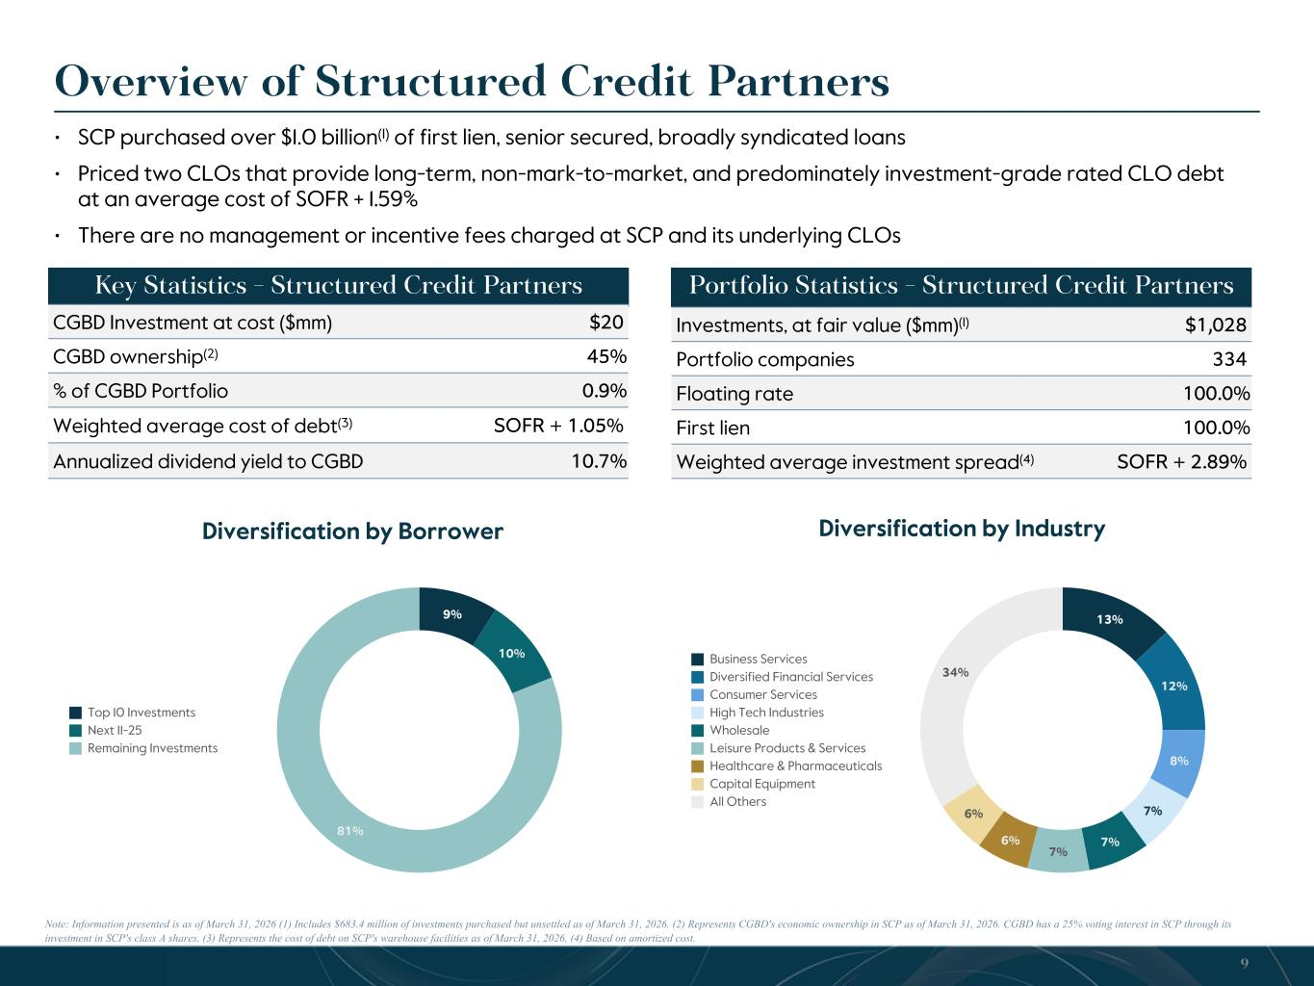
Note: Information presented is as of March 31, 2026 (1) Includes $683.4 million of investments purchased but unsettled as of March 31, 2026. (2) Represents CGBD's economic ownership in SCP as of March 31, 2026. CGBD has a 25% voting interest in SCP through its investment in SCP's class A shares. (3) Represents the cost of debt on SCP's warehouse facilities as of March 31, 2026. (4) Based on amortized cost. 9% 10% 81% Top 10 Investments Next 11-25 Remaining Investments 13% 12% 8% 7% 7% 7% 6% 6% 34% Business Services Diversified Financial Services Consumer Services High Tech Industries Wholesale Leisure Products & Services Healthcare & Pharmaceuticals Capital Equipment All Others Overview of Structured Credit Partners 9 Diversification by Borrower Diversification by Industry Key Statistics - Structured Credit Partners CGBD Investment at cost ($mm) $20 CGBD ownership(2) 45 % % of CGBD Portfolio 0.9 % Weighted average cost of debt(3) SOFR + 1.05% Annualized dividend yield to CGBD 10.7 % Portfolio Statistics - Structured Credit Partners • SCP purchased over $1.0 billion(1) of first lien, senior secured, broadly syndicated loans • Priced two CLOs that provide long-term, non-mark-to-market, and predominately investment-grade rated CLO debt at an average cost of SOFR + 1.59% • There are no management or incentive fees charged at SCP and its underlying CLOs Investments, at fair value ($mm)(1) $1,028 Portfolio companies 334 Floating rate 100.0 % First lien 100.0 % Weighted average investment spread(4) SOFR + 2.89%

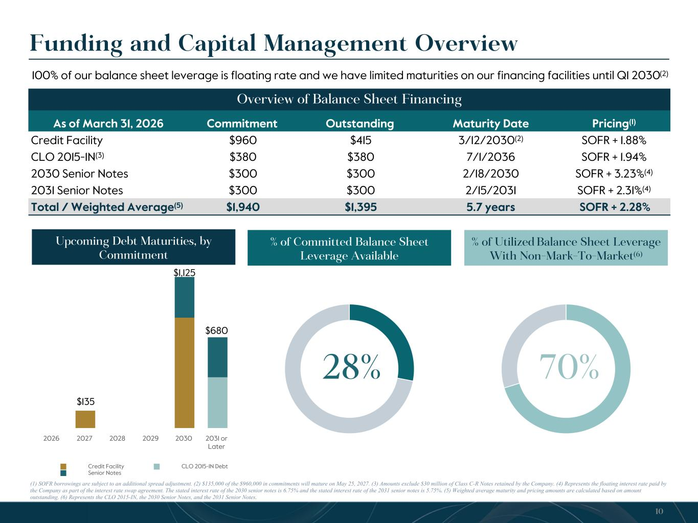
Funding and Capital Management Overview Overview of Balance Sheet Financing 10 As of March 31, 2026 Commitment Outstanding Maturity Date Pricing(1) Credit Facility $960 $415 3/12/2030(2) SOFR + 1.88% CLO 2015-1N(3) $380 $380 7/1/2036 SOFR + 1.94% 2030 Senior Notes $300 $300 2/18/2030 SOFR + 3.23%(4) 2031 Senior Notes $300 $300 2/15/2031 SOFR + 2.31%(4) Total / Weighted Average(5) $1,940 $1,395 5.7 years SOFR + 2.28% 28% % of Committed Balance Sheet Leverage Available % of Utilized Balance Sheet Leverage With Non-Mark-To-Market(6) (1) SOFR borrowings are subject to an additional spread adjustment. (2) $135,000 of the $960,000 in commitments will mature on May 25, 2027. (3) Amounts exclude $30 million of Class C-R Notes retained by the Company. (4) Represents the floating interest rate paid by the Company as part of the interest rate swap agreement. The stated interest rate of the 2030 senior notes is 6.75% and the stated interest rate of the 2031 senior notes is 5.75%. (5) Weighted average maturity and pricing amounts are calculated based on amount outstanding. (6) Represents the CLO 2015-IN, the 2030 Senior Notes, and the 2031 Senior Notes. 70% Credit Facility CLO 2015-1N Debt Senior Notes 2026 2027 2028 2029 2030 2031 or Later Upcoming Debt Maturities, by Commitment $135 $1,125 $680 100% of our balance sheet leverage is floating rate and we have limited maturities on our financing facilities until Q1 2030(2)

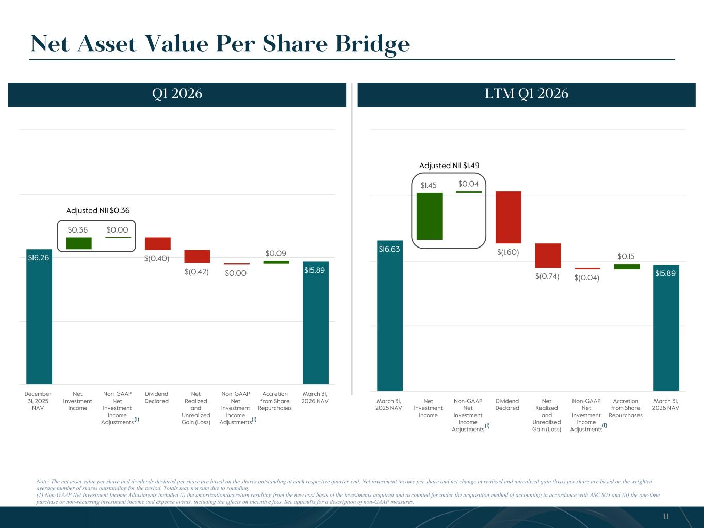
$16.26 $0.36 $0.00 $(0.40) $(0.42) $0.00 $0.09 $15.89 December 31, 2025 NAV Net Investment Income Non-GAAP Net Investment Income Adjustments Dividend Declared Net Realized and Unrealized Gain (Loss) Non-GAAP Net Investment Income Adjustments Accretion from Share Repurchases March 31, 2026 NAV Note: The net asset value per share and dividends declared per share are based on the shares outstanding at each respective quarter-end. Net investment income per share and net change in realized and unrealized gain (loss) per share are based on the weighted average number of shares outstanding for the period. Totals may not sum due to rounding. (1) Non-GAAP Net Investment Income Adjustments included (i) the amortization/accretion resulting from the new cost basis of the investments acquired and accounted for under the acquisition method of accounting in accordance with ASC 805 and (ii) the one-time purchase or non-recurring investment income and expense events, including the effects on incentive fees. See appendix for a description of non-GAAP measures. Net Asset Value Per Share Bridge LTM Q1 2026Q1 2026 11 $16.63 $1.45 $0.04 $(1.60) $(0.74) $(0.04) $0.15 $15.89 March 31, 2025 NAV Net Investment Income Non-GAAP Net Investment Income Adjustments Dividend Declared Net Realized and Unrealized Gain (Loss) Non-GAAP Net Investment Income Adjustments Accretion from Share Repurchases March 31, 2026 NAV Adjusted NII $0.36 Adjusted NII $1.49 (1) (1) (1) (1)

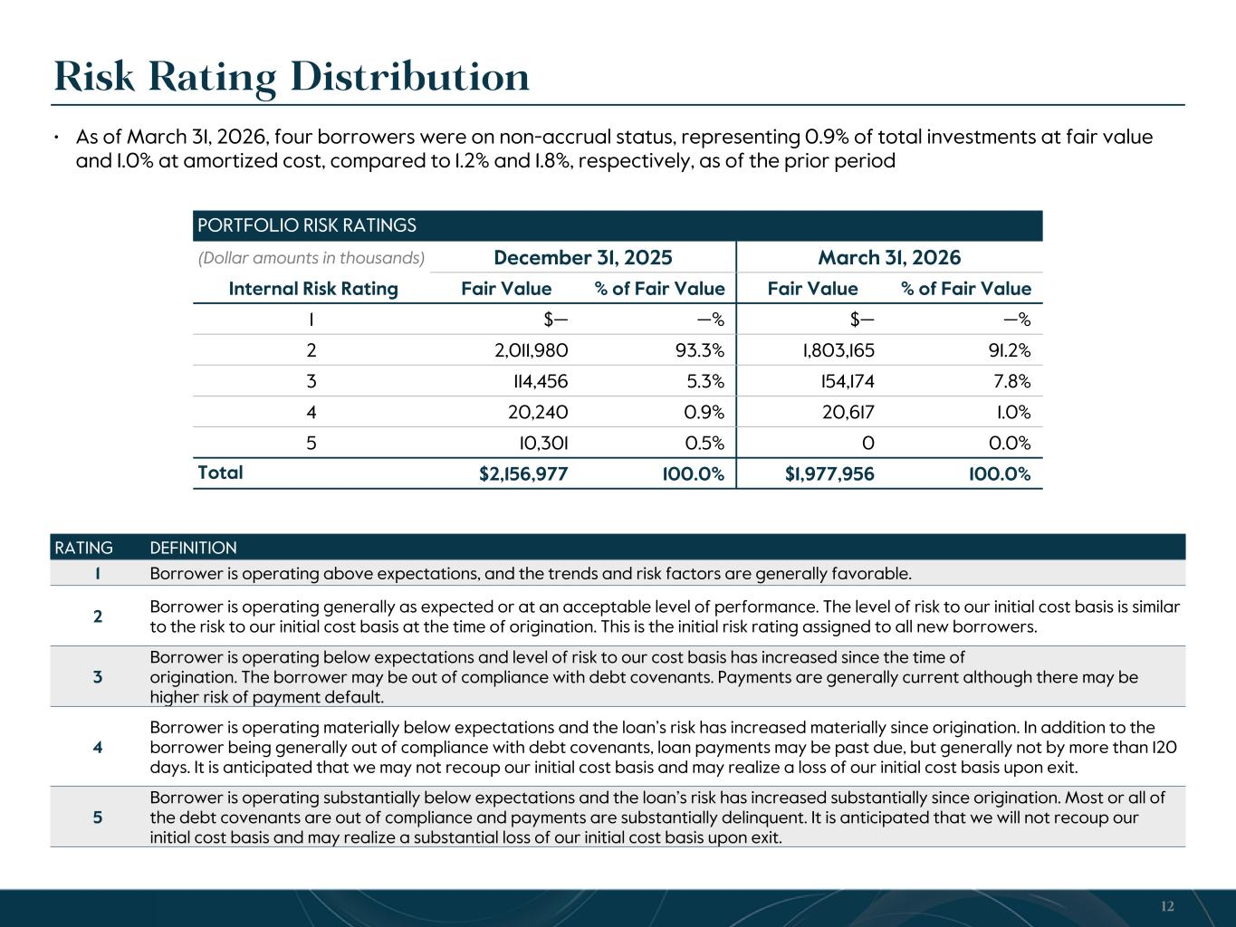
Risk Rating Distribution RATING DEFINITION 1 Borrower is operating above expectations, and the trends and risk factors are generally favorable. 2 Borrower is operating generally as expected or at an acceptable level of performance. The level of risk to our initial cost basis is similar to the risk to our initial cost basis at the time of origination. This is the initial risk rating assigned to all new borrowers. 3 Borrower is operating below expectations and level of risk to our cost basis has increased since the time of origination. The borrower may be out of compliance with debt covenants. Payments are generally current although there may be higher risk of payment default. 4 Borrower is operating materially below expectations and the loan’s risk has increased materially since origination. In addition to the borrower being generally out of compliance with debt covenants, loan payments may be past due, but generally not by more than 120 days. It is anticipated that we may not recoup our initial cost basis and may realize a loss of our initial cost basis upon exit. 5 Borrower is operating substantially below expectations and the loan’s risk has increased substantially since origination. Most or all of the debt covenants are out of compliance and payments are substantially delinquent. It is anticipated that we will not recoup our initial cost basis and may realize a substantial loss of our initial cost basis upon exit. PORTFOLIO RISK RATINGS (Dollar amounts in thousands) December 31, 2025 March 31, 2026 Internal Risk Rating Fair Value % of Fair Value Fair Value % of Fair Value 1 $— — % $— — % 2 2,011,980 93.3 % 1,803,165 91.2 % 3 114,456 5.3 % 154,174 7.8 % 4 20,240 0.9 % 20,617 1.0 % 5 10,301 0.5 % 0 0.0 % Total $2,156,977 100.0 % $1,977,956 100.0 % 12 • As of March 31, 2026, four borrowers were on non-accrual status, representing 0.9% of total investments at fair value and 1.0% at amortized cost, compared to 1.2% and 1.8%, respectively, as of the prior period

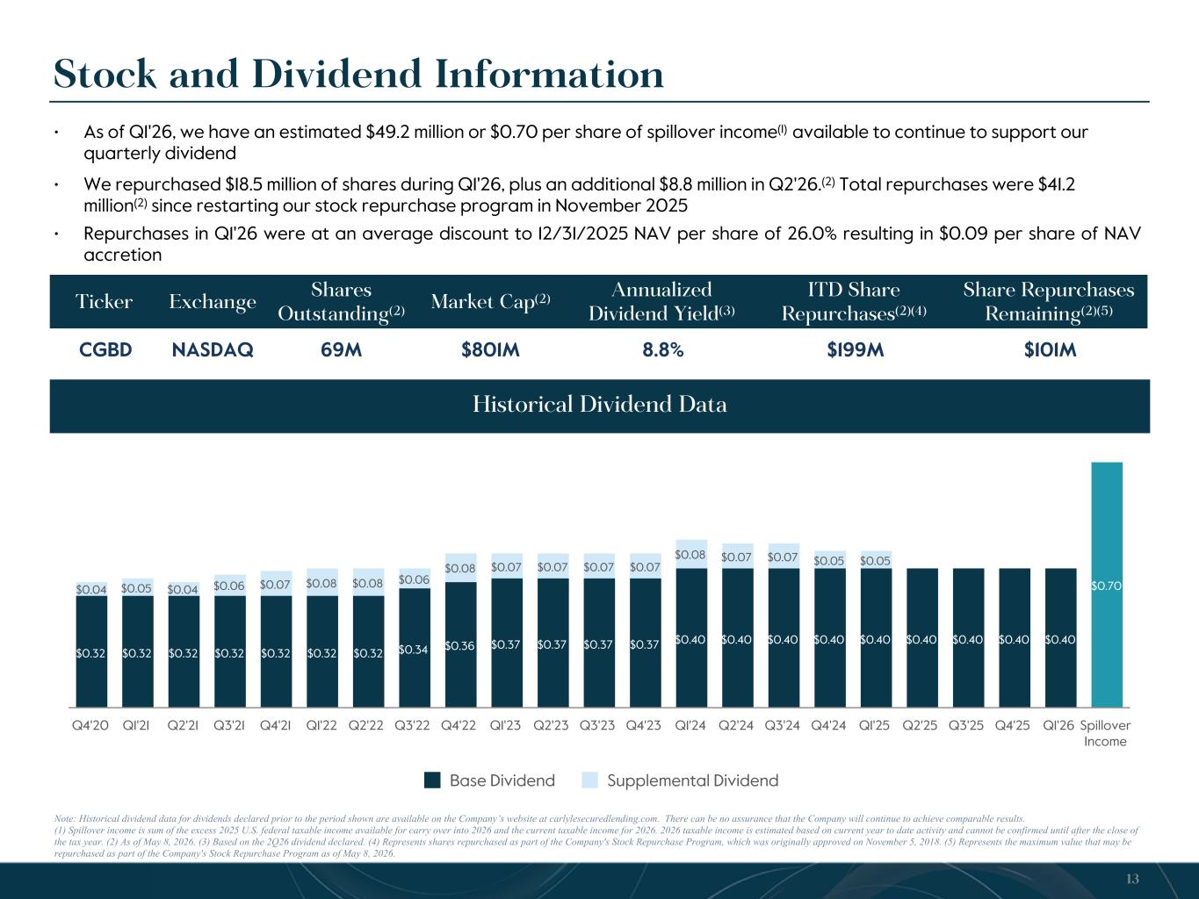
$0.32 $0.32 $0.32 $0.32 $0.32 $0.32 $0.32 $0.34 $0.36 $0.37 $0.37 $0.37 $0.37 $0.40 $0.40 $0.40 $0.40 $0.40 $0.40 $0.40 $0.40 $0.40 $0.70$0.04 $0.05 $0.04 $0.06 $0.07 $0.08 $0.08 $0.06 $0.08 $0.07 $0.07 $0.07 $0.07 $0.08 $0.07 $0.07 $0.05 $0.05 Base Dividend Supplemental Dividend Q4'20 Q1'21 Q2'21 Q3'21 Q4'21 Q1'22 Q2'22 Q3'22 Q4'22 Q1'23 Q2'23 Q3'23 Q4'23 Q1'24 Q2'24 Q3'24 Q4'24 Q1'25 Q2'25 Q3'25 Q4'25 Q1'26 Spillover Income Note: Historical dividend data for dividends declared prior to the period shown are available on the Company’s website at carlylesecuredlending.com. There can be no assurance that the Company will continue to achieve comparable results. (1) Spillover income is sum of the excess 2025 U.S. federal taxable income available for carry over into 2026 and the current taxable income for 2026. 2026 taxable income is estimated based on current year to date activity and cannot be confirmed until after the close of the tax year. (2) As of May 8, 2026. (3) Based on the 2Q26 dividend declared. (4) Represents shares repurchased as part of the Company's Stock Repurchase Program, which was originally approved on November 5, 2018. (5) Represents the maximum value that may be repurchased as part of the Company's Stock Repurchase Program as of May 8, 2026. Stock and Dividend Information 13 Ticker Exchange Shares Outstanding(2) Market Cap(2) Annualized Dividend Yield(3) ITD Share Repurchases(2)(4) Share Repurchases Remaining(2)(5) CGBD NASDAQ 69M $801M 8.8% $199M $101M Historical Dividend Data • As of Q1'26, we have an estimated $49.2 million or $0.70 per share of spillover income(1) available to continue to support our quarterly dividend • We repurchased $18.5 million of shares during Q1'26, plus an additional $8.8 million in Q2'26.(2) Total repurchases were $41.2 million(2) since restarting our stock repurchase program in November 2025 • Repurchases in Q1'26 were at an average discount to 12/31/2025 NAV per share of 26.0% resulting in $0.09 per share of NAV accretion

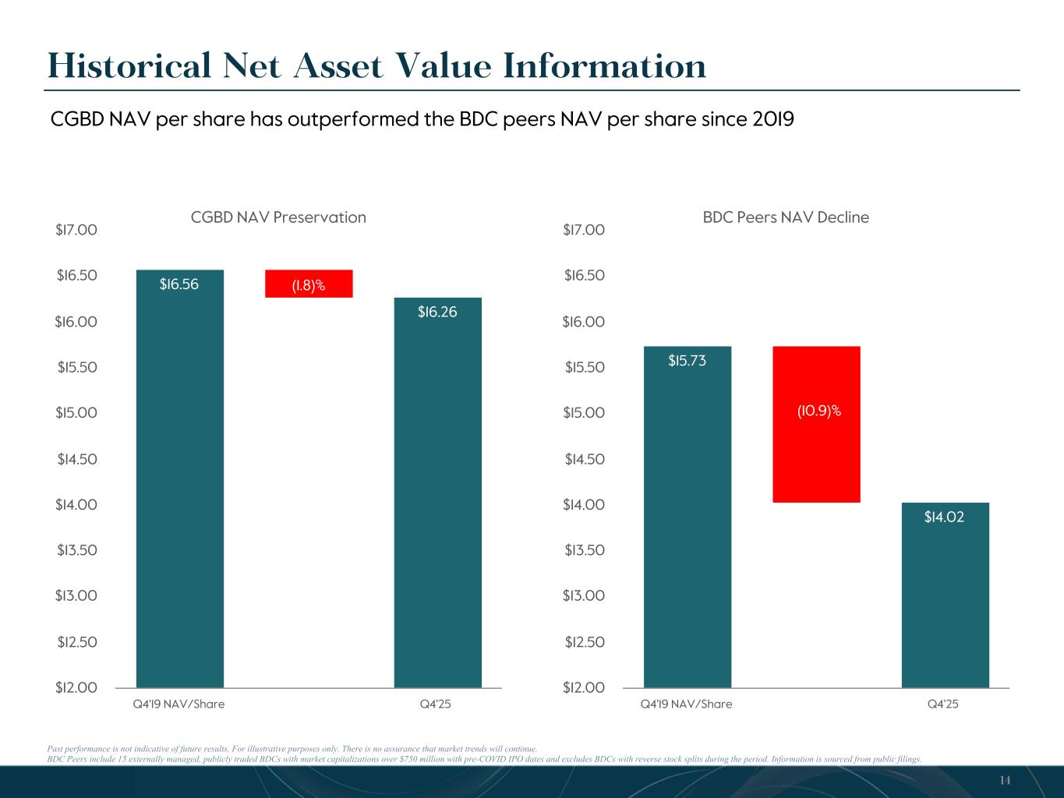
CGBD NAV Preservation $16.56 $16.26 Q4'19 NAV/Share Q4'25 $12.00 $12.50 $13.00 $13.50 $14.00 $14.50 $15.00 $15.50 $16.00 $16.50 $17.00 Past performance is not indicative of future results. For illustrative purposes only. There is no assurance that market trends will continue. BDC Peers include 15 externally managed, publicly traded BDCs with market capitalizations over $750 million with pre-COVID IPO dates and excludes BDCs with reverse stock splits during the period. Information is sourced from public filings. Historical Net Asset Value Information 14 BDC Peers NAV Decline $15.73 $14.02 Q4'19 NAV/Share Q4'25 $12.00 $12.50 $13.00 $13.50 $14.00 $14.50 $15.00 $15.50 $16.00 $16.50 $17.00 (10.9)% (1.8)% CGBD NAV per share has outperformed the BDC peers NAV per share since 2019


15 Appendix

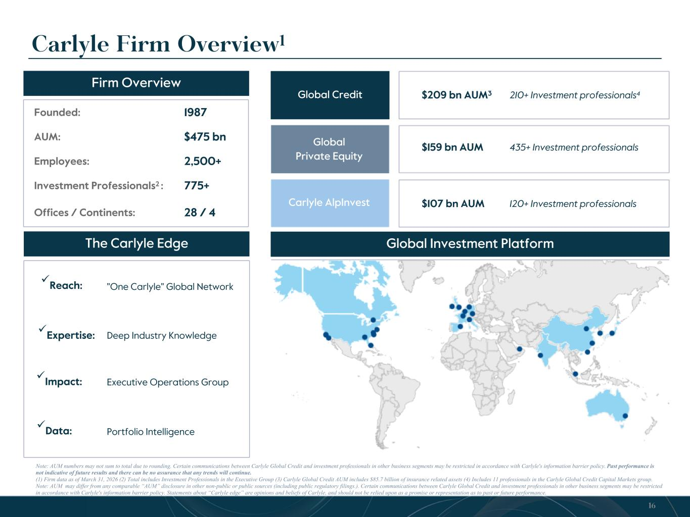
Carlyle Firm Overview1 Note: AUM numbers may not sum to total due to rounding. Certain communications between Carlyle Global Credit and investment professionals in other business segments may be restricted in accordance with Carlyle's information barrier policy. Past performance is not indicative of future results and there can be no assurance that any trends will continue. (1) Firm data as of March 31, 2026 (2) Total includes Investment Professionals in the Executive Group (3) Carlyle Global Credit AUM includes $85.7 billion of insurance related assets (4) Includes 11 professionals in the Carlyle Global Credit Capital Markets group. Note: AUM may differ from any comparable “AUM” disclosure in other non-public or public sources (including public regulatory filings.). Certain communications between Carlyle Global Credit and investment professionals in other business segments may be restricted in accordance with Carlyle's information barrier policy. Statements about “Carlyle edge” are opinions and beliefs of Carlyle, and should not be relied upon as a promise or representation as to past or future performance. Firm Overview Global Credit Global Private Equity Carlyle AlpInvest Founded: 1987 AUM: $475 bn Employees: 2,500+ Investment Professionals2 : 775+ Offices / Continents: 28 / 4 "One Carlyle" Global Network Deep Industry Knowledge Executive Operations Group Portfolio Intelligence $209 bn AUM3 210+ Investment professionals4 üReach: üExpertise: üImpact: üData: $159 bn AUM 435+ Investment professionals $107 bn AUM 120+ Investment professionals The Carlyle Edge Global Investment Platform 16

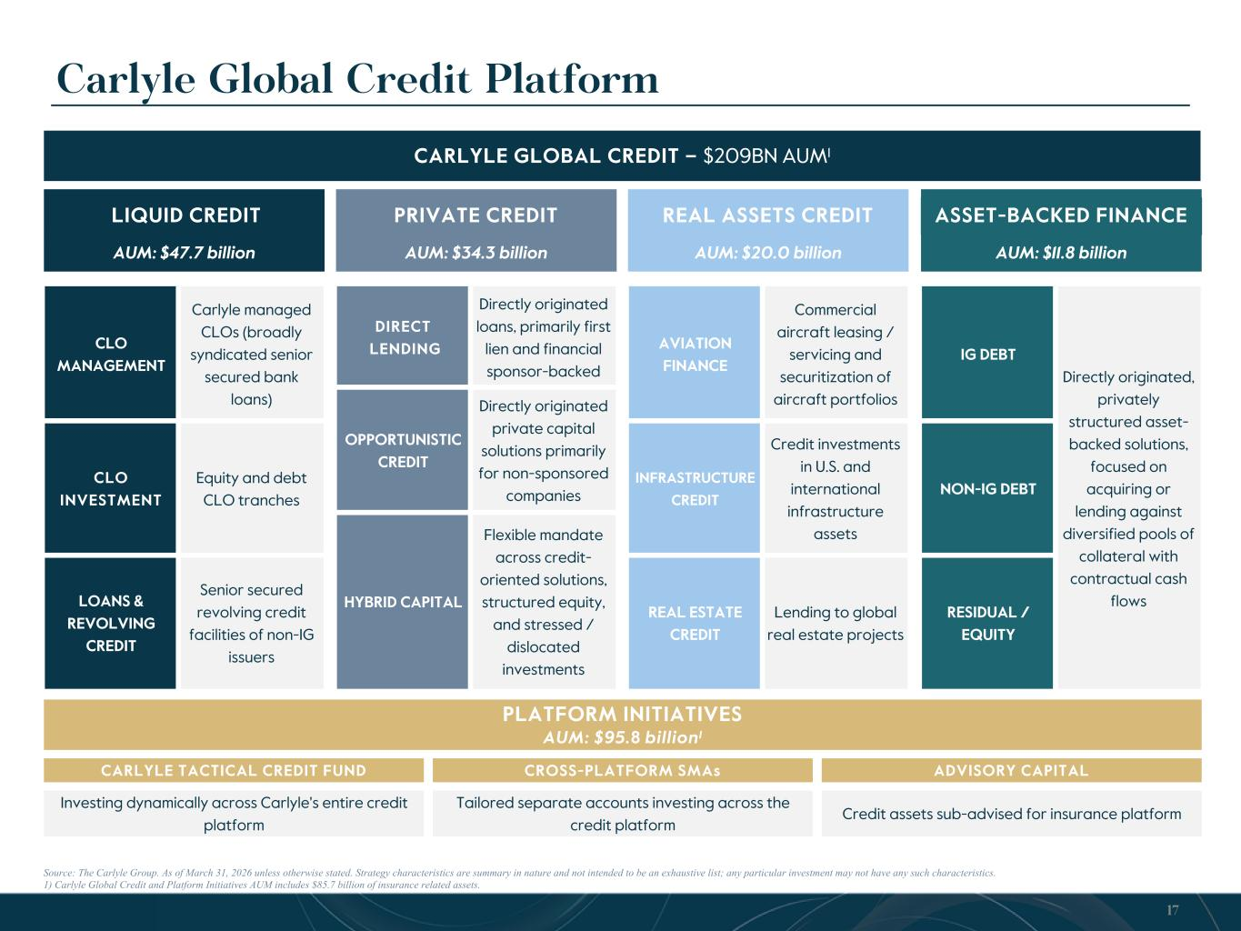
AUM: $11.8 billion ASSET-BACKED FINANCE Carlyle Global Credit Platform Source: The Carlyle Group. As of March 31, 2026 unless otherwise stated. Strategy characteristics are summary in nature and not intended to be an exhaustive list; any particular investment may not have any such characteristics. 1) Carlyle Global Credit and Platform Initiatives AUM includes $85.7 billion of insurance related assets. CARLYLE GLOBAL CREDIT – $209BN AUM1 AUM: $47.7 billion LIQUID CREDIT AUM: $34.3 billion PRIVATE CREDIT AUM: $20.0 billion REAL ASSETS CREDIT CLO MANAGEMENT Carlyle managed CLOs (broadly syndicated senior secured bank loans) CLO INVESTMENT Equity and debt CLO tranches LOANS & REVOLVING CREDIT Senior secured revolving credit facilities of non-IG issuers DIRECT LENDING Directly originated loans, primarily first lien and financial sponsor-backed OPPORTUNISTIC CREDIT Directly originated private capital solutions primarily for non-sponsored companies HYBRID CAPITAL Flexible mandate across credit- oriented solutions, structured equity, and stressed / dislocated investments AVIATION FINANCE Commercial aircraft leasing / servicing and securitization of aircraft portfolios INFRASTRUCTURE CREDIT Credit investments in U.S. and international infrastructure assets REAL ESTATE CREDIT Lending to global real estate projects PLATFORM INITIATIVES AUM: $95.8 billion1 CARLYLE TACTICAL CREDIT FUND CROSS-PLATFORM SMAs ADVISORY CAPITAL Investing dynamically across Carlyle's entire credit platform Tailored separate accounts investing across the credit platform Credit assets sub-advised for insurance platform IG DEBT Directly originated, privately structured asset- backed solutions, focused on acquiring or lending against diversified pools of collateral with contractual cash flows NON-IG DEBT RESIDUAL / EQUITY 17

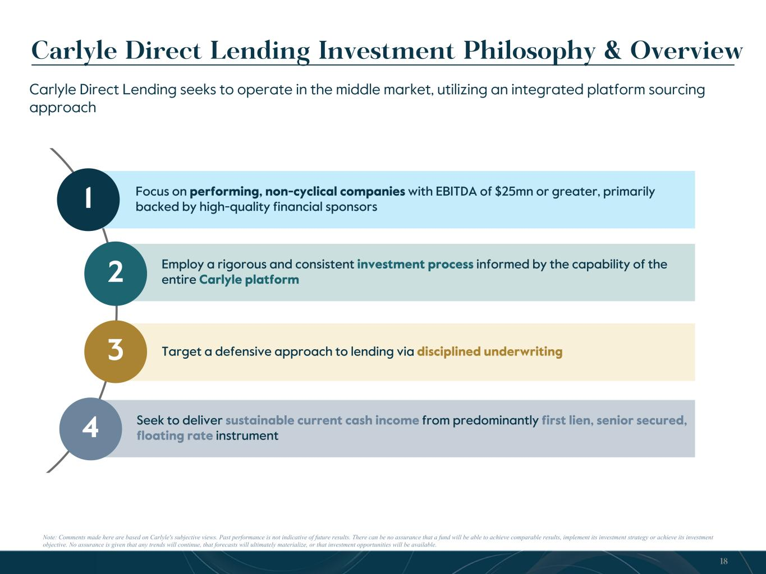
18 Carlyle Direct Lending Investment Philosophy & Overview Note: Comments made here are based on Carlyle's subjective views. Past performance is not indicative of future results. There can be no assurance that a fund will be able to achieve comparable results, implement its investment strategy or achieve its investment objective. No assurance is given that any trends will continue, that forecasts will ultimately materialize, or that investment opportunities will be available. Carlyle Direct Lending seeks to operate in the middle market, utilizing an integrated platform sourcing approach Employ a rigorous and consistent investment process informed by the capability of the entire Carlyle platform Target a defensive approach to lending via disciplined underwriting Seek to deliver sustainable current cash income from predominantly first lien, senior secured, floating rate instrument 2 3 4 Focus on performing, non-cyclical companies with EBITDA of $25mn or greater, primarily backed by high-quality financial sponsors1

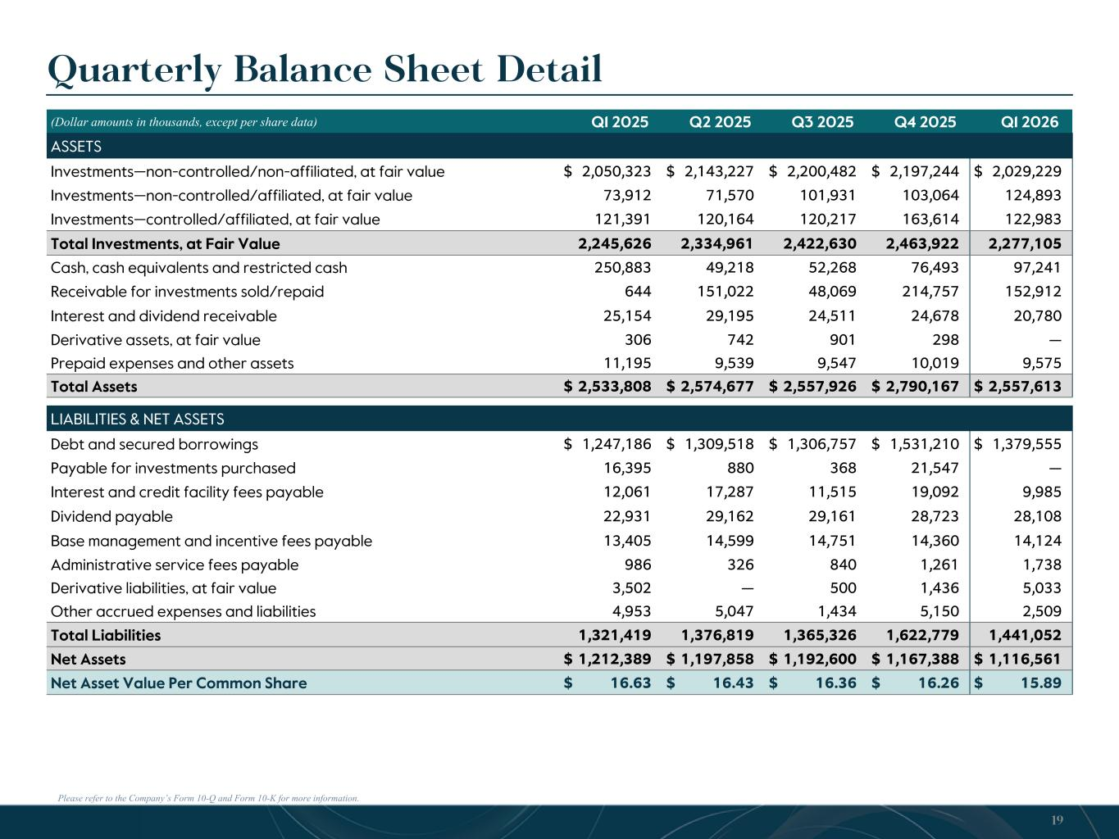
Please refer to the Company’s Form 10-Q and Form 10-K for more information. Quarterly Balance Sheet Detail (Dollar amounts in thousands, except per share data) Q1 2025 Q2 2025 Q3 2025 Q4 2025 Q1 2026 ASSETS Investments—non-controlled/non-affiliated, at fair value $ 2,050,323 $ 2,143,227 $ 2,200,482 $ 2,197,244 $ 2,029,229 Investments—non-controlled/affiliated, at fair value 73,912 71,570 101,931 103,064 124,893 Investments—controlled/affiliated, at fair value 121,391 120,164 120,217 163,614 122,983 Total Investments, at Fair Value 2,245,626 2,334,961 2,422,630 2,463,922 2,277,105 Cash, cash equivalents and restricted cash 250,883 49,218 52,268 76,493 97,241 Receivable for investments sold/repaid 644 151,022 48,069 214,757 152,912 Interest and dividend receivable 25,154 29,195 24,511 24,678 20,780 Derivative assets, at fair value 306 742 901 298 — Prepaid expenses and other assets 11,195 9,539 9,547 10,019 9,575 Total Assets $ 2,533,808 $ 2,574,677 $ 2,557,926 $ 2,790,167 $ 2,557,613 LIABILITIES & NET ASSETS Debt and secured borrowings $ 1,247,186 $ 1,309,518 $ 1,306,757 $ 1,531,210 $ 1,379,555 Payable for investments purchased 16,395 880 368 21,547 — Interest and credit facility fees payable 12,061 17,287 11,515 19,092 9,985 Dividend payable 22,931 29,162 29,161 28,723 28,108 Base management and incentive fees payable 13,405 14,599 14,751 14,360 14,124 Administrative service fees payable 986 326 840 1,261 1,738 Derivative liabilities, at fair value 3,502 — 500 1,436 5,033 Other accrued expenses and liabilities 4,953 5,047 1,434 5,150 2,509 Total Liabilities 1,321,419 1,376,819 1,365,326 1,622,779 1,441,052 Net Assets $ 1,212,389 $ 1,197,858 $ 1,192,600 $ 1,167,388 $ 1,116,561 Net Asset Value Per Common Share $ 16.63 $ 16.43 $ 16.36 $ 16.26 $ 15.89 19

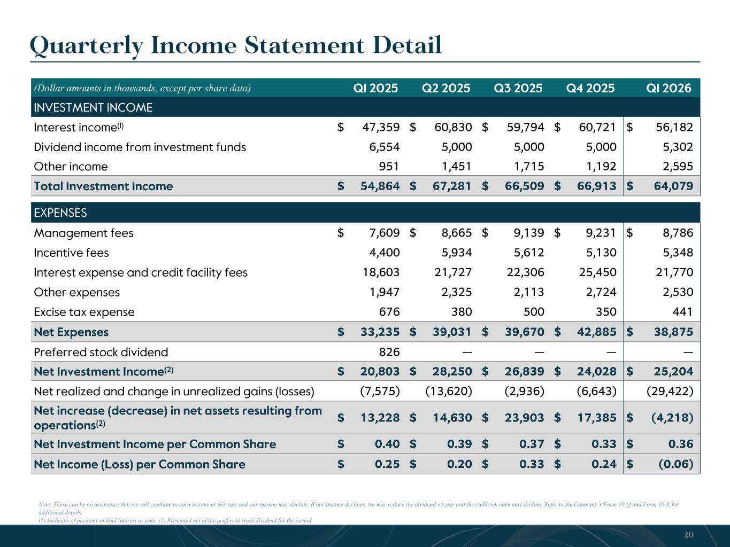
Quarterly Income Statement Detail Note: There can be no assurance that we will continue to earn income at this rate and our income may decline. If our income declines, we may reduce the dividend we pay and the yield you earn may decline. Refer to the Company’s Form 10-Q and Form 10-K for additional details. (1) Inclusive of payment-in-kind interest income. (2) Presented net of the preferred stock dividend for the period. (Dollar amounts in thousands, except per share data) Q1 2025 Q2 2025 Q3 2025 Q4 2025 Q1 2026 INVESTMENT INCOME Interest income(1) $ 47,359 $ 60,830 $ 59,794 $ 60,721 $ 56,182 Dividend income from investment funds 6,554 5,000 5,000 5,000 5,302 Other income 951 1,451 1,715 1,192 2,595 Total Investment Income $ 54,864 $ 67,281 $ 66,509 $ 66,913 $ 64,079 EXPENSES Management fees $ 7,609 $ 8,665 $ 9,139 $ 9,231 $ 8,786 Incentive fees 4,400 5,934 5,612 5,130 5,348 Interest expense and credit facility fees 18,603 21,727 22,306 25,450 21,770 Other expenses 1,947 2,325 2,113 2,724 2,530 Excise tax expense 676 380 500 350 441 Net Expenses $ 33,235 $ 39,031 $ 39,670 $ 42,885 $ 38,875 Preferred stock dividend 826 — — — — Net Investment Income(2) $ 20,803 $ 28,250 $ 26,839 $ 24,028 $ 25,204 Net realized and change in unrealized gains (losses) (7,575) (13,620) (2,936) (6,643) (29,422) Net increase (decrease) in net assets resulting from operations(2) $ 13,228 $ 14,630 $ 23,903 $ 17,385 $ (4,218) Net Investment Income per Common Share $ 0.40 $ 0.39 $ 0.37 $ 0.33 $ 0.36 Net Income (Loss) per Common Share $ 0.25 $ 0.20 $ 0.33 $ 0.24 $ (0.06) 20

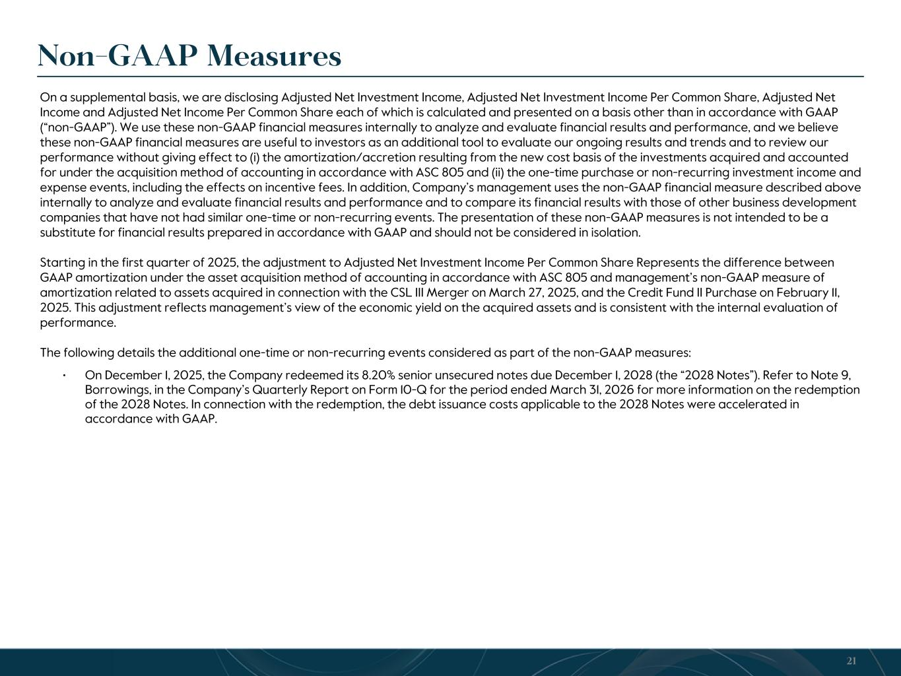
On a supplemental basis, we are disclosing Adjusted Net Investment Income, Adjusted Net Investment Income Per Common Share, Adjusted Net Income and Adjusted Net Income Per Common Share each of which is calculated and presented on a basis other than in accordance with GAAP (“non-GAAP”). We use these non-GAAP financial measures internally to analyze and evaluate financial results and performance, and we believe these non-GAAP financial measures are useful to investors as an additional tool to evaluate our ongoing results and trends and to review our performance without giving effect to (i) the amortization/accretion resulting from the new cost basis of the investments acquired and accounted for under the acquisition method of accounting in accordance with ASC 805 and (ii) the one-time purchase or non-recurring investment income and expense events, including the effects on incentive fees. In addition, Company’s management uses the non-GAAP financial measure described above internally to analyze and evaluate financial results and performance and to compare its financial results with those of other business development companies that have not had similar one-time or non-recurring events. The presentation of these non-GAAP measures is not intended to be a substitute for financial results prepared in accordance with GAAP and should not be considered in isolation. Starting in the first quarter of 2025, the adjustment to Adjusted Net Investment Income Per Common Share Represents the difference between GAAP amortization under the asset acquisition method of accounting in accordance with ASC 805 and management’s non-GAAP measure of amortization related to assets acquired in connection with the CSL III Merger on March 27, 2025, and the Credit Fund II Purchase on February 11, 2025. This adjustment reflects management’s view of the economic yield on the acquired assets and is consistent with the internal evaluation of performance. The following details the additional one-time or non-recurring events considered as part of the non-GAAP measures: • On December 1, 2025, the Company redeemed its 8.20% senior unsecured notes due December 1, 2028 (the “2028 Notes”). Refer to Note 9, Borrowings, in the Company’s Quarterly Report on Form 10-Q for the period ended March 31, 2026 for more information on the redemption of the 2028 Notes. In connection with the redemption, the debt issuance costs applicable to the 2028 Notes were accelerated in accordance with GAAP. Non-GAAP Measures 21

